Emotionally Adaptive UI/UX for Menstrual Cycle Tracking: A Longitudinal, Mixed-Methods Study of Phase-Linked Affective Variation and Its Design Implications
Shreyash Patekar
MCA, KJ SOMAIYA OF MANAGEMENT, Mumbai
Abstract—Most menstruation tracking apps treat the cycle as a data entry challenge, which dates entered and forecasts generated. This process is one of the few repeating human experiences that continuously alters mood, vitality, and self-perception, although it is rarely treated as an emotional one. This research investigates the variations in women's emotional states during the menstrual cycle, as well as the implications for interfaces built to support, rather than log. Ten active participants (aged 18 to 35) conducted 22 check-ins over a 30-day period using organised Google Forms, ranking their emotional status, physical comfort, energy, and mental attention on a 1-10 scale with open-ended questions. Quantitative research revealed a continuous affective spectrum, with a follicular-period well-being high, a monthly trough marked by a 68% energy decline, and a luteal. phase that was not consistently difficult, but bimodal, with people alternating between calm and anguish. Thematic coding revealed phase-specific emotional fingerprints as well as other patterns that departed from the medical stereotype, most notably the fact that life stress consistently outweighed hormonal phase and subjective "brain fog" was accompanied by reasonably preserved self-rated attention. The behavioural analysis was similarly revealing: retention dropped 83% before the last check-in, rapid responders outperformed detailed responders, and 80 percent refused to answer libido-related questions. More than half of the group showed signs of melancholy and did not communicate with their spouses about the cycle. We incorporate these results within an emotional responsive design framework and a suggested application, NurtureSync, in which interface language, micro-interactions, check-in time, and support information are tailored based on the client's current phase and emotions load. This paper is not a declaration that empathy-aware design is novel in the broader sense, but rather a grounded description of what emotional requirements exist, how they vary, and the manner in which an interface might address them without delving into clinical terrain.
Index terms include affective designing, emotive computing, menstruation observation, UX investigation, private informatics, long-term studies, mood, adaptable interfaces, FemTech, and mental health.

I. Introduction
In general, digital devices can forecast many biological processes that occur in our bodies. A menstrual cycle tracker can accurately estimate when a person will have their period. However, it will not anticipate the user's emotional state during their cycle. This research was motivated by an unmet design need.
Currently, there are numerous menstrual cycle monitoring applications on the market with a variety of capabilities. Most are large-scale calendars that keep track of when users started, when they are expected to be fertile, when they are expected to finish bleeding, and any symptoms entered by the user. As product developers, we presume that everyone is addressing their company's concerns. One especially intriguing aspect of menstrual cycle tracking is that almost everyone finds it difficult to relate to emotionally. Menstruation is largely a physical event, but it is also associated with a wide range of emotional sensations. As a result, developing a product that only displays a calendar and gives information about it will not provide consumers with the emotional support they require when they are on their period.
Designing a product based on the user's emotional experience is not a new concept. Donald Norman recognised three types of emotional responses when utilising a product: visceral, behavioural, and introspective.There are numerous HCI applications [1] that describe how emotion plays a role in interaction and creates unique emotional experiences. They contend that emotion is an essential component of product functionality, rather than just a way to adorn a product with extra features. There is relatively little study on how these theories are used in a cyclical, emotionalised domain, however the menstrual cycle has been recognised as an acceptable setting for an experimental interface test due to its emotional predictability.The study began with a design probe investigating the development of emotionally intelligent interfaces, but as more information about the predictability of the menstrual cycle became available, the focus shifted to the menstrual tracking domain, which provided a repeatable standard emotional model that could be developed into a robust response mechanism. Rather than making assumptions during the development process, the project began with primary data obtained from a longitudinal study of how real women reported their cycles in their native language during the previous several weeks. The study's key research aims included learning:RQ1: How do women's physical comfort, emotional mood, energy level, and mental clarity change during the phases of their menstrual cycle, and do those changes vary greatly amongst individuals?RQ2: How do women characterise their emotions and suffering during the four stages of their menstrual cycle, and how do such descriptions differ from the clinical mental image of the menstrual cycle?RQ3: What do women track as part of their menstrual cycle, what do they not track, when do they cease tracking their menstrual cycle, and what evidence does the data provide concerning friction in current tools?RQ4: How may empirical data be leveraged to make concrete interface design decisions for a menstrual cycle tracker with emotional adaptability?The paper will be organised as follows: a description of relevant literature, methodology, themed sub-sections for expanded presentation of the findings, theme-based discussion, and a design section that connects the qualitative themes and findings to the design of the interface elements within the proposed application. We have taken care to describe the research sample and provide explicit descriptions of the level of trust in the data for drawing final findings and/or suggestions.
II. RELATED WORK AND BACKGROUND
This paper presents the study's context within the framework of three research areas: affective and expressive planning, emotional neurology of the menstrual cycle, and the private informatics literature on monitoring and disengagement. The report follows with an overview of how this study addresses a research gap.
A. Emotion and Affective Design.
According to Norman's definition of visceral, behavioural, and cognitive creation/processing [1], usefulness is defined by both feel and functionality; thus, the ways a thing feels first (directly) and over time (reflectively), combined with its enjoyment level, ultimately determines whether the product is usable. In that sense, it is correct to say that the way that a human works with an emotionally intelligent device will be more logical than conversing with an insane computer; this is an area Picard researched, with sympathetic computing being one of the outcomes [2]. Later research in "Human Computer Interaction" identified emotion as an essential part of interaction between humans and computers [3]. People, such as Walter,, have written concerning their interactions with emotional objects, providing real-world instances of how a psychological attraction with an object,, through personality traits and resonance, can result in feelings of belonging to that item, as in Walter's example [4]. Other writings by Hassenzahl distinguishes between pragmatic and hedonic development [5]; a gadget may work, but if it does not produce a hedonic profit from a the investment made, the client is unlikely to desire return. Höök defines affective circuits [6] as a mutually generated emotional connection between the user and the system through repetitive interaction, which is especially relevant for a tool that is used multiple times.
.
The hormone effect that has on the emotional component of a woman's cycle stages (period, fertility, reproduction, ovulation, and luteal processes) is documented and centers on four emotional events that are frequently labelled by cycle phases: "Diminished" during menstruation, "Energising" over follicular stage, "Optimal" during ovulating, and the "PMS" while the luteal stages. However, the cycle is more complex than traditional empirical data would suggest. Furthermore, prospective evaluations of mood through the menstrual cycle reveal no consistent adverse effects on mood during that luteal phase; contrary, the link between the luteal period and bad feelings appear to be weaker and more variable than previously thought. Most of women do not experience an ongoing decline in their premenstrual mood. Similarly, there is quite little consistency in women's cognitive function during the menstrual cycle, though there are certainly some effects that are negligible when compared to the variance in performance throughout individual women. The most severe physiological manifestation of this condition is premenstrual dysphoric syndrome. [13], Nonetheless, this minority doesn't encompass all individuals, nor will it fully convey my thoughts on global concept of maleness, nor does it's reflect the significance of designing a menstruation environment. As an example, an environment that assumes the majority of readers have some degree of menstrual problem will most likely result in less true representations of the reader's actual circumstances than if the writer's emotional state was not mentioned in the context's design.
C. Tracking, Personal Informatics, and Disengagement
The published material on individual informatics takes a different view on self-tracking than many people believe. Tracking is viewed through the lens of a stage model, because proposed by Li, Dey, and Forlizzi, as a process that occurs in multiple stages: preparation, disposal, integration, standardisation, and execution. At any of the above stages, the user has the option to stop going any further. According to Epstein (2003) and others, people frequently abandon and begin tracking, and a significant amount of technology fails at the action-to-idea stage, where data collected by tracking transforms into meaning. The menstrual watching study carried out by Li, Dey, and Forlizzi focused on how women's necessity of tracking goes far beyond predicting when their period will occur. These women desired to grasp the significance and context of their bodies, but the technology available did not always meet their expectations. A similar acknowledgement of the challenges associated with the use of sensitive data for estimating birthrates and developing cycle technologies supports many users' long-standing concerns about the delicate nature of the information captured by these programs and the effects of such information on their lives. The more typical definitions such as usability and convincing design failed to account for the goal of applying the definitions in the daily use of highly emotional, privacy sensitive products.
D. Research Gap
There were three gaps observed. First, while designing to feed emotions is widely discussed in the abstract, it is rarely applied to a real-world cyclical environment (an emotional context that changes on a regular basis), so there may be a connection that can adapt to this periodic change. Second, while there is data in the literature supporting the idea that each stage of a cycle have real effects, these outcomes vary so that when organisations design "trackers" for observing people, they are prone to use only one kind of user, despite the fact that numerous users exist. Third, while the literature on private computing provides insights into why people cease using gadgets or trackers, it fails to account for the unique emotional et public privacy constraints associated with documenting menstruation. The study attempts to fill all three gaps by using longitudinal data of how women responded with cycle recording and how phase tracking enabled a more emotional responsive design..

III. METHODOLOGY
Applying a Permanent Mixed Technique Design to Identify a Dynamic Variable. Periodic hybrid studies are intended to investigate the growth of a thing over a set period of time. Because enquiries are not an ideal instrument for identifying a cycles (because patterns only arise over many consecutive weeks), the investigators utilised repetition among all the respondents; thus, the duration of the collection was cut into five phases of time alongside the intention to ensure that each milestone would place a person in a different stages of development stage (i.e., cycle), and conducted a combination of quantitative analyses along with individual reflections to establish a space for data to be addressed.
A. Instrument Design
For gathering data, a standardised Google form was used, which included one screening questions and four check-in sheets. The screening questionnaire collected information on participants' gender band, calendar regularity, average period length, current phase day, and any recent menstrual issues they had. At each check-in, participants rated four metrics ("emotional state, physical relaxation, energy level, as well as mental focus) on a scale of 1 to 10. Participants also checked off items on a checklist of symptoms of illness, mental states, changes in mood, sleep routines, and social interest. Finally, participants were asked to complete open-ended questions about how they felt and why. A few issues, including libido, were taken into account to examine potential blind spots of the monitoring mechanism; however, these did not yield useful data as each participant chose not to respond to this question, leaving little to no insight about their responses.
This gadget was created to assist the user in identifying their menstrual cycle while keeping a record of the date it is and asking consumers directly on an application what cycle day it is. This resulted in inconsistencies among the people surveyed who used this product. Testing the app's results revealed who had a healthy or regular cycle and allowed them to explain the significance of their findings.
B. Participant Selection and Screening
Every one of the participants volunteered and received no financial reward for their time. Participants' emotions were expected to vary depending on their age group, so they were divided into four age groups: teens (10 to 17), younger people (18-25), adults (26-35), and older adults (35+, including pre-menopause). This division was necessary for lumping any of these women into a single group would have obscured the difference on emotional responses when compare aged women to old men. The final sample consisted primarily of women aged 18 to 35, showing a clustering between 18 and 25. Furthermore, a few of the women had consistent menstrual cycles, whereas others had unpredictable cycles. Two of our screening people were diagnosed having PCOS, a condition, and one of them had concurrently acquired PMDD. However, however, either of these people checked in, so there were no check-ins in the study. The energetic control sample is summarised in Table 1.
Characteristic | Category | n
Age band | 18–25 | 7
 | 31–35 | 1
Cycle regularity | Regular | 5
 | Irregular | 3
Check-ins done | 4 of 4 | 1
 | 3 of 4 | 5
 | 1–2 of 4 | 2
Diagnosed cond. | PCOS / PMDD* | 2
TABLE I. Composition of the active sample (8 participants, 22 check-ins). *Screened only; no check-ins completed.
C. Data Collection Process
Each of the four check-ins were expected to take about 30 months each (in terms of ovulation times and their relationships to menstruation, follicular, ovulatory, luteal, and normal cycles). At first, the fulfilment of each check did not seem equal; they wanted participants to recall their past experiences and provide an impression of what they remember and had experienced in the same classification, as there had been no automated notifications or feedback of participation. This design flaw eventually emerged as a significant behavioural finding in the study. .
D. Emotional Mapping and Analytical Approach
The undertaking was evaluated using two independent techniques: qualitative and quantitative methods. The quantitative evaluation focused on the formulation of descriptive stats for ratings on a 0 to 10 scale to summarise the data that was collected on a per phases base (as well as per person basis) and to take into account these evaluations on a per-phase along with participant basis (a single per participant was added if they had no less than three check-ins). Although the sample size of respondents was insufficient to conduct implicit statistical tests, ratings provided were taken as descriptive or signal-based, rather than proof of anything. Qualitative examinations of open-ended responses via subjects were also organised according to theme by phase, encompassing the following items: emotional parts that appeared frequently throughout the phases, certain word choices/rates adopted by subjects, painful areas identified by subjects, and unfulfilled needs expressed or proposed by subjects. Once the two different analyses concluded, they were juxtaposed with each other, providing additional insight into the participants' difficulties. Specifically, how symbols can represent one thing while words may muddy or confuse the message. .
IV. FINDINGS AND DISCUSSION
These findings were arranged by theme rather than session. The perimeter of each meeting was first measured, then the emotional material behind the arc was reviewed across the arc, then variability that affects any simple linear narrative was assessed, and finally all behavior/mental health and relationship ( the quite things that additional procedures tend to ignore) in order to provide a more complete and comprehensive account of every detail being investigated. The order in which each session was developed will be removed (so that all dataset participant IDs - P001/P003, for example) will be recognised with their quotes exactly as is. .
A. The Quantitative Arc: A Clear Cyclical Pattern in Wellbeing
The data show that women's standard of life varies depending on her cycles. A woman's quality of lifestyle is highest throughout a follicular stage of her development in three areas: emotion, physical comfort, and mental focus, and there is little variation between other women in the identical phase as her. When women's quality of life is at its pinnacle, they will achieve nearly equal degree of success. In contrast, a woman's level of life is at a minimum during her menstrual period, with a substantial decline in quality scores over her affective & energy levels.
Due to the data collection, women's energy state decreases on average (by 68%) after she transitions from follicular to monthly phase; integrating other females did not provide enough variability in outcomes for this sort of transition. A woman's physical ease will decrease by 53% as she transitions from the follicular to menstrual phase. The data indicate that the rate of recovery from a low point of standard of life is swift in this population, as these individuals regularly experience a rapid recovery to quality of existence decline over her follicular with menstrual transition; however, given how deep the peak loss of level of life is, the length of the decline is comparatively short.
One parameter moved during this evaluation, while mental attention remained above 5.6 across the cycle, with a monthly low. A pause is warranted in this case, as those who went through a whole cycle of "mind fog" rated their degree of engagement to be only mildly committed to the task or activity, despite being noticed with a cloudy/glazed appearance. The break between integers or words stems from a disconnect; experiencing brain fog does not imply that your cognitive function has been disrupted. The design of any GUI used or contemplated should show a user recognition of the user's fog, rather than pushing inability to perform tasks adequately as a person. Table II contains period averages, which are provided for reference.
Phase (days) | Emot. | Comf. | Energy | Focus
Menstrual (1–5) | 4.8 | 4.0 | 2.6 | 5.6
Follicular (6–14) | 8.4 | 8.7 | 8.0 | 8.7
Ovulation (~14)† | 5–8 | 5–9 | — | —
Luteal (15+) | 6.2 | 6.2 | 6.0 | 6.6
TABLE II. Mean self-rated wellbeing by phase (1–10). †Ovulation reported as a range given n=3.
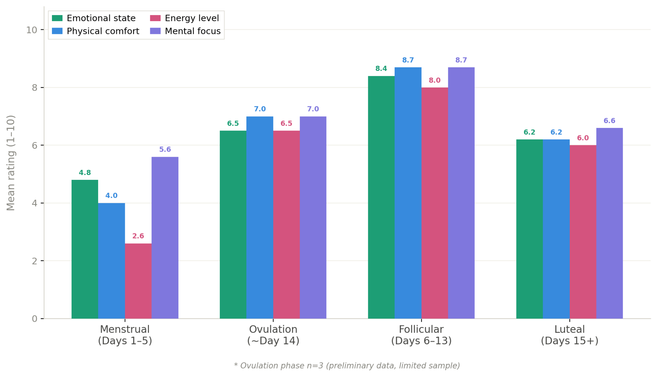
Fig. 1. Average wellbeing ratings across cycle phases, illustrating the follicular peak and the menstrual energy trough.
B. The Emotional Texture Behind the Numbers
The ratings show the cycle's structure, while the open-ended responses describe what it's like to live in it. We retrieved four phase fingerprints.
Menstruation read as overwhelm and depletion. Menstruation was associated with feelings of overwhelm, fatigue, and, most significantly, a debilitating sense of tiredness. Weariness was usually the dominant feeling, yet it developed into physical pain because fatigue and discomfort were frequently experienced concurrently. One participant said, "I feel happy at first and afterwards before a period I am really disinterested and then I think nothing and I feel every bit of that." Another said, "I have awful abdominal tenderness on day one, and it takes me throughout the entirety of the day to find the opportunity to try and relax, but being connected to my family means that I'm always currently doing anything at that point and therefore it can be a stressful day for me." 83% of participants who reported cramping during this time period said it had no emotional impact on them. .
The follicular phase read as uplift. The transition to coping to flourishing: "Very detailed and directed," "There certainly is no fear," a, "Calm mode of thinking," "At all no deliberation or agitation." Eighty-two percent of those interviewed here reported no mood changes. All of the remaining very poor respondents during this period of time demonstrate that their negative reports were due to a different external stressor; but they may have made a distinction, which we will revisit.
Ovulation read as paradox, but the data are thin. Using only three responses, little is to be inferred, but one of the responses focusing on a person who judged themselves in a psychological level of 5 of a possible 10 (sad/low ) but stated that they felt "strong and emotional today" generates a lot of proof indicating that this single answer may indicate a state of feeling with a one-dimensional gauge (mood). .
The luteal phase read as a storm—for some. The present research yielded a tremendous amount of qualitative data, as evidenced by one participant's report of their experience. "At my luteal stage epoch, my emotions swing like a Ferris wheel, but the manner in which my mood shifts every second is what makes it harder for me to know how I felt at any moment. For example, as I type this, I am largely pleased and relaxed, although in the back of my thoughts, I have concerns about a situation I can't explain, which is very frustrating; thus, I am experiencing a variety of emotions right now." The luteal phase caused brain fog of altered the amount of compassion and self-criticism. Some participants stated that, whereas the luteal phase produces speeds and slowness throughout their phase of being, the key distinction between expressing fast and slow is determined by the woman's level of stress.
C. Variability Is the Finding, Not the Noise
To properly describe the luteal part of the menstrual period, one must first understand how women feel in each of the four different menstrual cycles. That is no material to suggest that luteal phases emotions change greatly nor that this phase was created to be routinely classified as easy or difficult. While studies have been conducted to determine how many women experience different kinds of emotional reactions to their luteal troughs, the average emotional response to luteal phases varies, with roughly forty-four percent self-expressing calm or serene emotions and 33% reporting expressing angry or irritable emotions. The mean difference of women reporting emotions during respective luteal cycles is approximately 0.88, whereas the standard error of women indicating economic responses in their menstrual phases is roughly 2.4. As a result, what he really is psychological reaction (or lack thereof) related to the luteal - phase is based on personal interpretation rather than any specific menstrual phase.

This trend persisted in data gathered in multiple locations and reflecting a health care reference standard. One-third of those who took part in this current study study reported feeling serene and calm throughout their menstrual period, even the menstrual phase, which directly contradicts the clinical or pathology-based literature. Anxiety during the various phases of the cycle of menstruation, on the other hand, has consistently been recorded at similar levels, indicating that the stress linked to the events occurring in each phase of the cycle is the only source of that individual's anxiety. The main finding from all data sets revealed that outside stressors consistently exceeded all phases within the menstrual cycle. Participants frequently experienced fatigue and anxiety in the early stages of the ovarian cycle when taking tests or travelling, and they stated that coupling the demands of a full-time position with those of an luteal phase often resulted in worse outcomes than "cry for help" scenarios. In other words, women are not progressing during their menstrual cycles is predicted by models.
The empirical proof supports the case toward individualised design—not as a commercial concept, but as an essential architectural imperative. If there is between-subject variability, nearly every one of the average individuals will deviate significantly from the mean in this very large, average-sized population. Tools must additionally tailor the parameters they require to reflect an individual user's norms and variance data, rather than telling them what their luteal period "is." This outcome is the underlying motivator for the majority of the layout decisions developed in Section V.
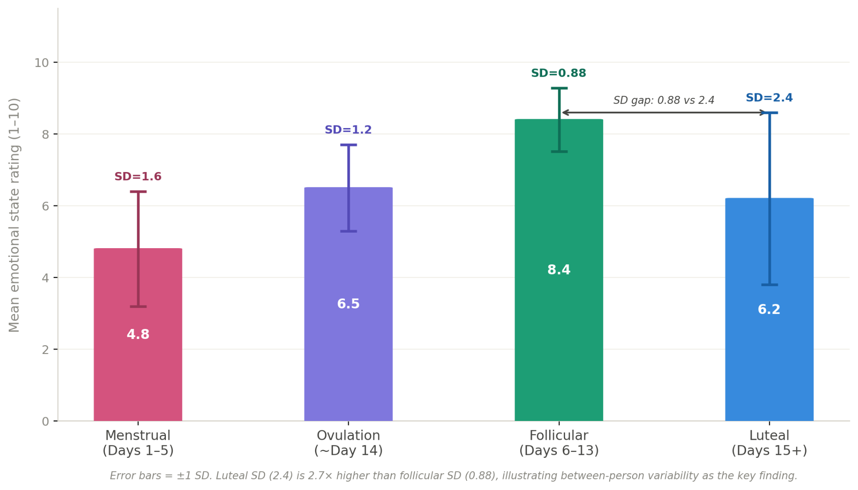
Fig. 4. During the luteal phase, the main finding is variability, not the mean. Mean emotional state ratings are shown with ±1 SD error bars by cycle phase.
D. Tracking Behaviour, Friction, and the Privacy Line
This study sought to observe how people felt. It ended up being an unforeseen, unbiased analysis of disinterest through a method by which people dropped out of the study, or "dipped out." There was 100% retention at check-in 1, but at check-in 4, we found only twelve percent retention, amounting in an 83% crash. This collapse happened between the third and fourth check-ins. The findings are summarised in Table III. .
Check-in | Participants | Dropouts | Retention
1 | 8 | 0 | 100%
2 | 7 | 1 | 87.5%
3 | 6 | 1 | 75%
4 | 1 | 5 | 12.5%
TABLE III. Participant retention across the four check-ins.
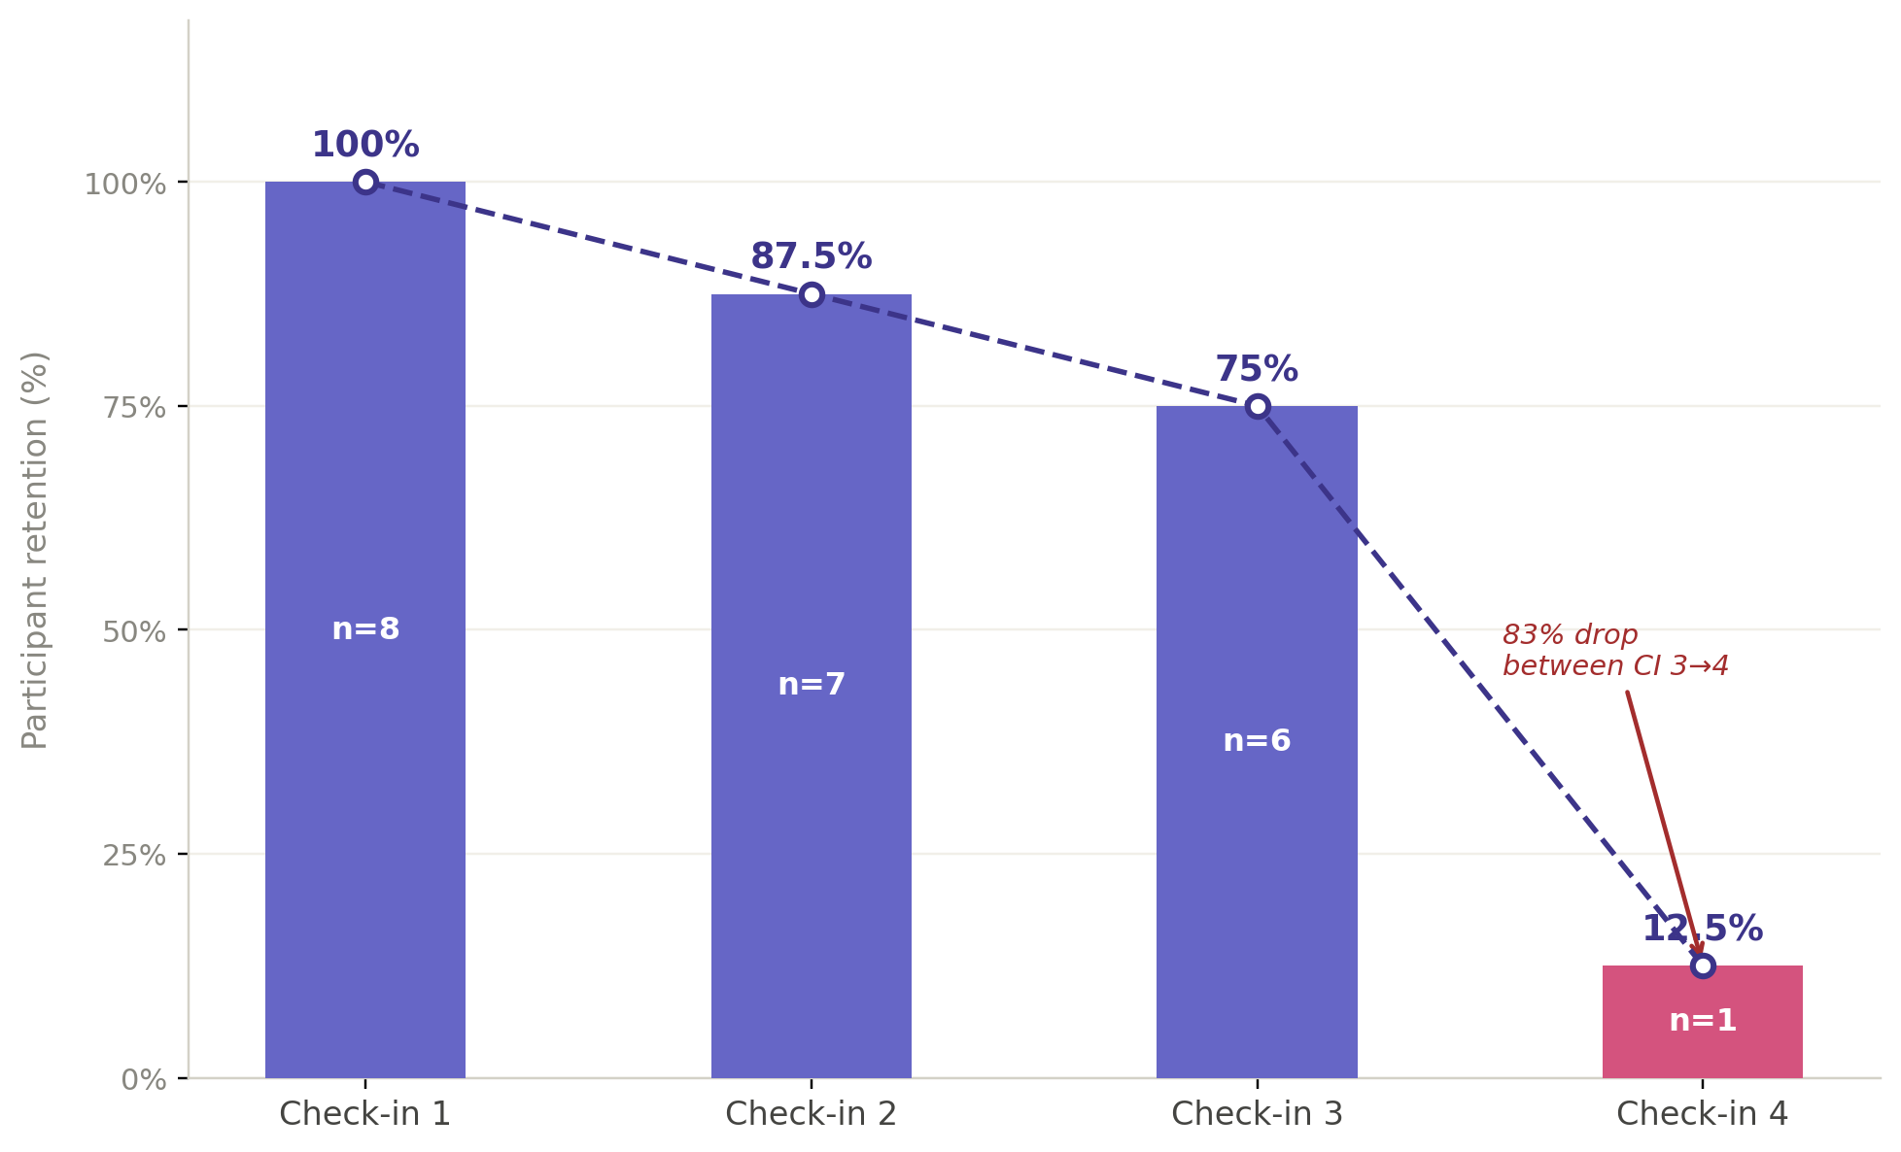
Figure 3. User retention over four check-ins. The dropout rate between check-ins 3 and 4 was 83%..
The data collected provides a variety or reasons that everyone can relate to, which should instill confidence that the challenges will be resolved. The inspections were lengthy (15+ questions), and the longer length was associated with participants failing to complete the entire check-in. Participants received no feedback immediately after submitting their answers, so the opportunity that was failed to foster a sense of self-discovery; rather, it provided them with a chore to complete. There were no prompts used to help participants remember and answer the questionnaires as time went on. Furthermore, when respondents' tracking data revealed the most severe manifestations, such as those of a 2 out of 10 rating based on extreme degrees of luteal flare-up symptoms (P001) and significant rates of anaesthesia (P004), monitoring opportunities were eliminated.
One counterintuitive result deserves emphasis because it inverts a natural design assumption. In the straightforward case, detailed explanations of findings remained (while the majority of participants completed expressing participation before 1.5 times the usual amount of participants entered). Individuals who submitted 80-100+ paragraph testimonies averaged 1.5 registrations, while those who submitted 5-15 words averaged 3.3 registrations before discontinuing the study. Unluckily, the subjects who generated the most complete information were the first to abandon the data-collection process, while the bland, basic subjects completed their data-collection endeavours. As a result, any researcher looking for quality data cannot expect a high level of comprehensiveness from a consumer with limited time to write a citation. As a result, a longitudinally triggered technique demanding a longitudinal-design will require less time to construct a citation of it would typically by no more than a yearly requirement in all phases where longitudinal data must be collected.
Privacy drew a hard line. 80% of the participants didn't react to the passion item. A majority selected to say, "I would not state anything," rather than leaving their response open; this reveals an intentional rejection to respond, not an unintentional omission. Even those who shared their profound sentiments chose to decline this single inquiry. When thinking of social desire questions, 30% were overlooked or omitted. In contrast, the graphical scales and ticks completed in 95%-100% of the time due to their rapid nature and lack of exposure. The lesson follows: women are reluctant to divulge private details, but rather do not want to be mandated to do so, and that either the way something is framed or whether or not it allows for some degree of choice in how it is answered has an important effect of whether as well not a solution is provided.
E. Mental Health and Emotional Support Needs
Mental health and well-being were prevalent across the study. Of the eight people surveyed, 63% reported feelings of depression such as low mood, apathy, fatigue, and anhedonia; 50% indicated major anxiety; and half had evidence-stress-sensitive symptoms that intensified when exposed to psychological stimuli associated with living. As a result, none of these examples can be deemed "extreme outlier experiences" if an individual's regular experience includes using a tracker to manage their feelings (via the tracker's default tone).

Two example features (P001 and P010) are particularly useful in grasping the way a user's tracker might be designed.
P001's experience was similar to that of someone suffering from premenstrual dysphoric condition (PMDD); she had low mental function (2 out of 10) and fast-changing PMDD-associated mood cycling, but she also demonstrated significant awareness of oneself and self-compassion in her coping strategies for depression.
P010, on the other hand, had all of the most hazardous risk factors: physical depression and mood swings (such as "I am happy for a moment, but eventually quickly switched to empty and numb"), antidepressant use, and significant distress about her body image (such as "I don't like where my body looks, don't like that I have a few spots on the skin, and I don't admire the way my stomach looks"). She did not return after one check-in; thus, the individual with a low relative emotional state also proved to be the quickest to discontinue a tracker, indicating a clear need for crisis-informed, empathetic design aspects as well as a reduced friction model for gathering emotion-tracking data.
Many people discussed the concept having coping methods during interviews. Common solutions mentioned include compassion for yourself, refocusing the situation, quitting, or simply perseverance. All of such tactics may be effective in difficult situations, although they are either partial or dangerous. Only a few people admitted to employing empirically supported coping strategies. As a result, it is clear that an app's intended use should not be therapy, but rather to assist users in accessing short-term scientifically proven coping micro-tools when needed (e.g., grounding, respiration exercises, and rapid reframes), as well as clearly established, consistent paths toward specialised services. The app's intended use needs to be explicitly specified in the design section, as the software support what it does not treat.
F. Relationships and the Communication Gap
There had been a relational divide between information set and the individuals. Each participant reported a cycle of incidents that had an impact on their relationships, such as irritability and social withdrawal, cancelled social plans, and unexpressed needs; however, no participant reported raising any of these difficulties with their spouse and other relatives. P001 stated that close relatives were aware of her distress ("I felt really deprived of control the entire time...I am going through a strange kind of mental disarray....I didn't say much"), but they didn't help her pinpoint the source of their irritation. P004 did not report feeling tired, and the pattern was repeated without understanding the feedback loops or consequences.

All of these mistakes seem predictable and cause havoc. Any changes in one's mood will be seen as a personal onslaught; physical anguish will be interpreted as an excess; withdraw from close companions will be regarded as rejection; and fluctuating arousal can be seen as a lack of interest. Each of these can create new intellectual gaps between one's experience and that of their partner, allowing them to be "connected" through data suggesting the app can't provide. As a result, these describe the general potential what designers can provide through the research investigated, and thus can meet each of the clinical goals stated above with methods that are consistent with ethical norms of care to everyday goods, such as giving a woman alongside words to express herself and possibly making it easier for her to express her intentions with their partners.
V. FROM FINDINGS TO DESIGN: AN EMOTIONALLY ADAPTIVE FRAMEWORK
The intent of a grounded research method is to base all decisions on findings rather than desires. This section describes NurtureSync's practical use case, from persona data to framework. Each of the conceptual decisions listed below refers back to information from which it was derived.

A. Five Personas Grounded in the Data
After separating our sample, we discovered five major user segments (based on symptom severity, regularity, and emotional characteristics). Table IV shows actual groups within the real world. .
Persona | Maps to | Profile | Primary need
Warrior | P003, P006 | Minimal symptoms; stable, high ratings across all phases | Planning and pattern awareness
Sufferer | P001, P004 | Severe pain and mood volatility; disrupts daily life | Pain/emotion regulation; predictive warnings
Curious Tracker | P005, P009 | Resilient but stress-reactive | Separate cycle from stress effects
Irregular Cycler | P0007, P010 | Unpredictable cycles; uncertain about phase | Symptom-based phase detection; reassurance
Sensitive Responder | P010 | Mental-health vulnerable; at risk of disengaging | Compassionate tone; crisis routes; minimal friction
TABLE IV. Personas derived from participant segmentation.
The Warrior demands too much of information without depth, whereas the Acute Respond wants no details at all and will leave if asked for it. This next ecological adaptation claim assumes that both sides can be served by an identical (fixed) interface structure.
B. The Framework: Three Axes of Adaptation
The proposed framework adapts along three axes derived directly from the findings.
1) Adapt to phase. Every phase of an individual's body is tied with an emotion (identifying B), which affects the interface itself (tone, colour, microcopy, and content), all of which are related to the person's current body phase. Thus, the affect-loop concept [6] takes place within a system capable of anticipating the affective loop.
2) Adapt to the individual, not the average. Because of the significant degree of individualised variation among people, and because the luteal phase has 2 sides (Finding C), the method is designed to lay a personal foundation instead of trying to establish population norms. That is, it cannot predict whether a specific user is a luteal uncomfortable or a luteal defective that thrives. It will learn through them (discovering C), but will see external factors as a regulator of their previous knowledge rather than the source of a "bad day" caused by hormonal influences.
3) Adapt to emotional load and effort budget. Users who use Find D drop out due to friction, whereas brief comments result in resilience with D. The system is designed to not charge for brief messages and instead increases the depth of chats for users who explicitly ask for it. On certain days when things are harder to do as well as think about and a user doesn't need to complete it, it will not censure them when an unfinished question is assigned to them.
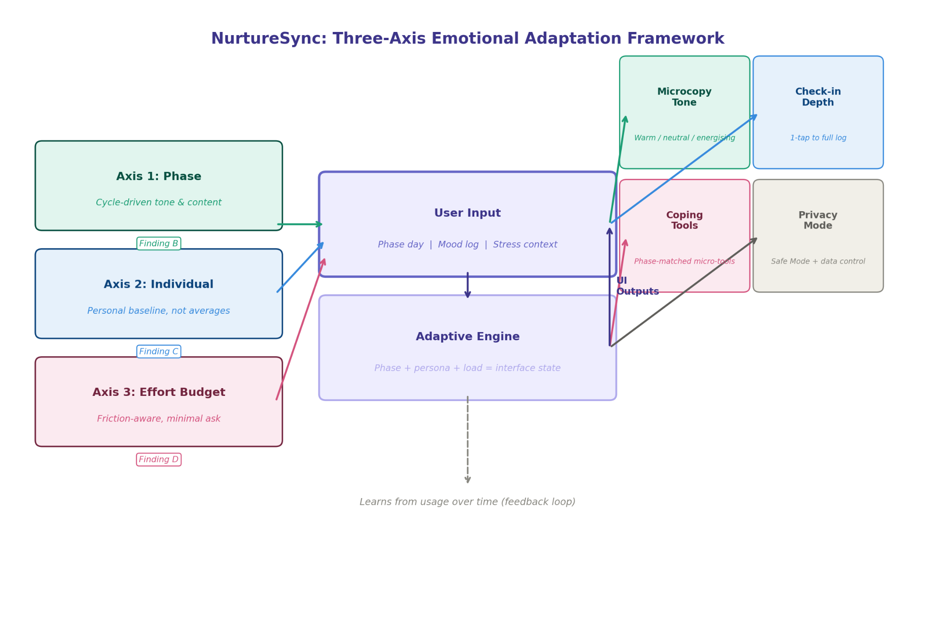
Fig.5. The three-axis emotional adaptation framework that NurtureSync is based on, translating empirical results into interface design decisions.
C. The Proposed Application: NurtureSync
Users who use Find D drop out due to friction, whereas brief comments result in resilience with D. The system is designed to not charge for brief messages and instead increases the depth of chats for users who explicitly ask for it. On certain days when things are harder to do as well as think about and a user doesn't need to complete it, it will not censure them when an unfinished question is assigned to them. .
Tiered, low-friction check-ins. According to how engaged the user is, completing the three to five questions on the usual login page takes less than two minutes. The short-response and retention issues are directly related to the program's request for less through the standard login page (Knowledge-D). You retain the user longer if you seek for less data on the initial login page. .
Emotion logging with cause-tagging. People frequently note what they think is causing feelings when they record their emotions. They may be experiencing cramps, anxiety at school, exhaustion, hanging out with friends and having a particular food need, PMS, or no particular reason at all. By distinguishing between the alleged causes of various mood disorders and their physiological impacts, tagging these emotions aids users and the algorithm in making this study's most significant contributions (Finding C) to the conventional understanding of data pertaining to the physiological impacts of mood disorders.
Contextual coping micro-tools. Short choices, such breathing, stretching for five minutes in order to earn a complete five minutes, resting, listening to music, or conversing with others, are presented to the user after low verification. Given the results that there are not enough readily available coping resources (determining E) to achieve adequate levels to be therapeutic, these are intentionally offered as minimum and non-directive alternatives. .
Compassionate, non-amplifying microcopy. Instead of being apocalyptic (catastrophizing), the messages derived from insights should be confirmative (confirmation). For instance: "Day 2 during your cycle is usually when you feel apathetic." That's typical. However, you should speak with a responsible adult if you still feel that way." This case offers two insights: This manifests as feelings rather than a shortage of ability, and the extent to which you feel brain fog is significantly higher than the real brain fog (Insight Find A). Along with contributing to the scenario's mildness, the target audience sample's lower age and greater emotional susceptibility to feeling similarly produce a "obvious" tone (Insight Discovery E).
Privacy-first architecture and Safe Mode. In conjunction with offering a Safe Mode that enables users to conceal the app's activity by making its messages less noticeable and demanding a PIN or biometric authentication lock for entering and/or entry to any of the app's content, the application offers the ability to designate, flag, along with tone down the display of sensitive subject matter. These features are intended to lower the 80% amount of lip service provided, offer more user preferences for "Privacy" and "Intimacy" data, as well as more user preferences for disclosing sensitive process data, as previously demonstrated [8], and help the user determine personnel-level restrictions on accessing their private information.
Optional partner and support sharing. Users can bridge communication gap by writing a quick statement of what a specific stage'means' to them. They may also wish to communicate this with a preferred partner, family member, or friend (Finding F). As consequence, the synopsis will be 'user authored' and created as the female narrates her own tale rather than someone else's for her benefit.
The specialized tool types follow a similar logic: a Warrior will use strategic planning tools, whereas a Sufferer will use a forecasting alert system for strategic planning along with will be able to document their pain; a Curiously Monitor will have stressful integration capabilities with a way to track it; the Irregular Cycler, meanwhile, will use symptom-driven systems to identify phase symptoms; and a Sensitive Responders will use caring, low-impact methods and clear availability of available resources during a crisis. Figure 2 displays the point of the user interface where every one of these actions will take place.
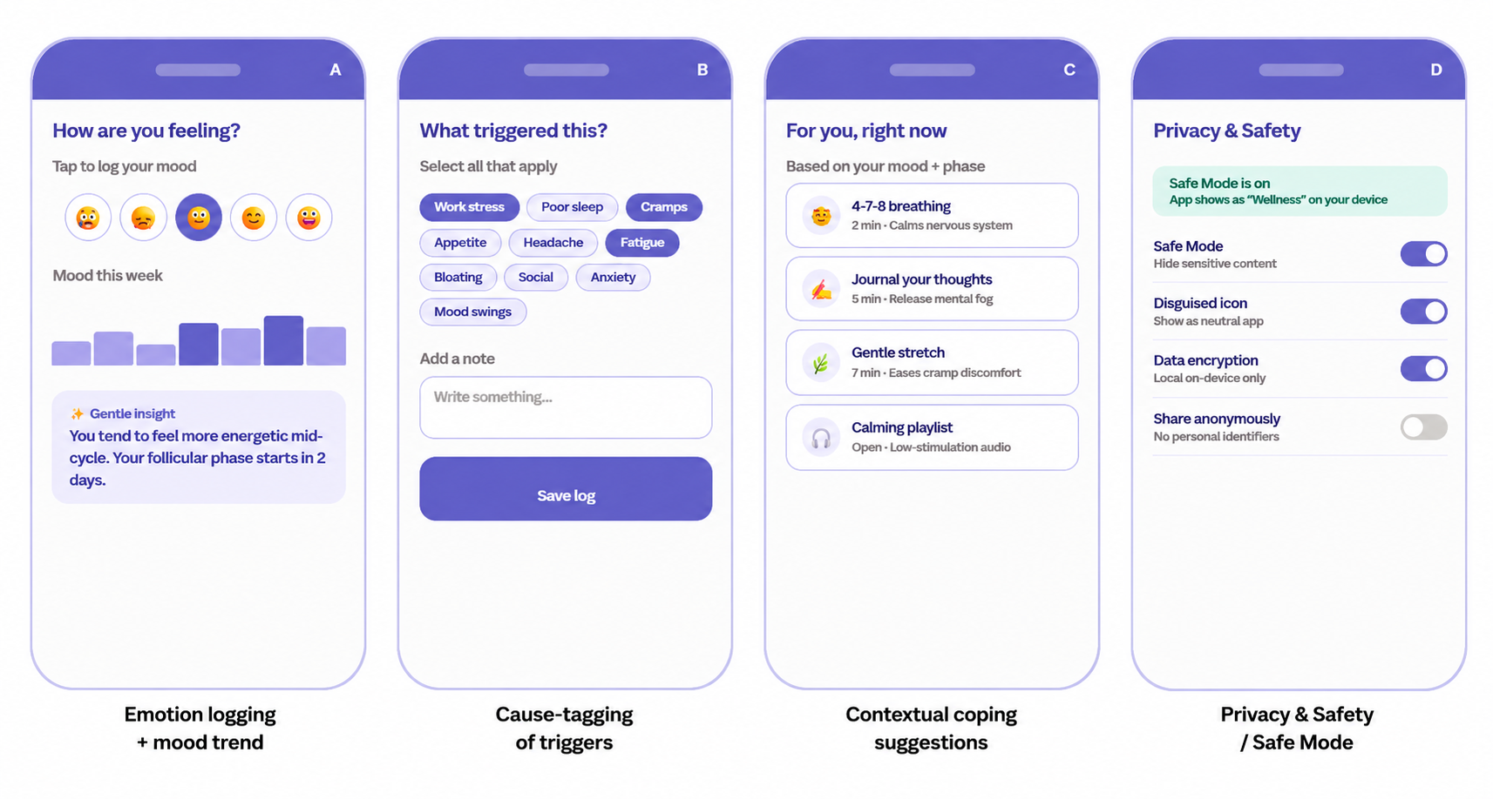
Fig. 2. Representative NurtureSync screens: emotion logging with mood trend and a non-alarming insight card; cause-tagging of triggers; contextual coping suggestions; and the Privacy & Safety / Safe Mode controls.
VI. LIMITATIONS
The limitations are genuine, and they should be recognized without qualification. The population size is modest, with only eight active subjects and 22 check-in individuals (from the initial sample). Thus, while anecdotal analysis is possible, statistical generalizations cannot be drawn. Any information offered should be interpreted as hints to these 30 people, not as estimates for the wider population. Because the sample has a bias toward younger persons aged 18 to 25, any conclusions obtained about adults or older people (such as perimenopause) are based on either no or minimal evidence. Because participants left the study at a high rate (for reasons beyond their control) and declined out (especially those who had become very sick or fragile), it is probable that the remainder (individuals who were very well and were coping) influenced the media/phase data that could be submitted. The phase identification for every participant was based on the stated cycle day. The reported menstrual day was erroneous for those who experienced irregular periods and required the most specific phase identification (e.g., PCOS and PCOS), preventing them from submitting check-in reports (when likely to worsen a cycle experience). Finally, all the variables studied were self-reported, cross-sectional, and retrospective, therefore the standard issues of employing retrospective "+/+" research will arise when self-reporting to + satisfy recollection. The incapacity of a respondent to reply to libido surveillance indicates that there may be information that may otherwise have already been disclosed.
VII. FUTURE SCOPE
We have various natural pathways forward. The top priority is to conduct longitudinal (more lengthy, larger, and more age-diverse) study, preferring a platform or instrument that returns a value to the participant, because, as the study's dropout rate demonstrates, not providing returns hampers subjects retention and participation in research studies. Furthermore, the targeted enrollment of PCOS, PMDD, and menopausal users will cover study gaps and is expected to yield information on needs above the current group as a whole. In terms of design, the NurtureSync structure should be experimentally tested to see if using Phase-Adaptive Tone coding improves user memory retention or personal support when compared to a static based interface, as well as whether Cause-Tracking helps distinguish users' perceived stress-related effects from those caused by their cycle. The components of Communication with Your Partner that were mentioned in the data but have not been tested should also be studied to see if having a shared cycled summary reduces relational misconceptions. Finally, the stress-modifier finding lends support to the establishment of a collection of passive indications (sleep, activity level, and calendar load) that can be utilized to predict tough days without increasing the reporting burden on participants.
VIII. CONCLUSION
This study sought to determine how women's feelings fluctuate over her monthly cycle, what additional emotional issues are associated with those fluctuating changes, and how social supports designed to assist a woman in managing her period can help with such emotional issues. Women's menstrual cycles follow a curve. It is a rise in follicular hormone levels, which causes an increase in energy levels, followed by a tapering off of energy levels. This is with the commencement of the menstrual cycle and finally a return to high energy levels following ovulation. However, a particularly interesting discovery in this study is how difficult the luteal stage can be in women. The luteal stage can be very challenging because women can feel at peace or facing a number of difficulties during this phase, and outside stressors during this stage can have a bigger effect on an individual's media consumption than her hormonal levels, emphasizing the fact that the women's cycles vary for woman and the reality that there is no one cycle that works for all women.
"Making the app passionate' is an incorrect design conclusion since it has an above-average level of error. A better match would be to create a design to be individual and responsive to their stage, which will be somewhat predictable given surroundings in a social environment; individualized in order that women cannot depend on averages to help them independently; and limited because behavioral behaviours indicate that if you solicit your users to feed less, they will continue to be in a slow progression—mainly since privacy is a higher priority than good, and a psychological supporting service needs to be significant NurtureSync is one example of this notion, which is an effort that seeks to hold the values of design in'soft' when alluded to as tender,'soft' when alluded to as having to be quiet, and 'explicit' when the limitations are left out of parenthesis but not used in that format. However, proceeding with this demands consideration of methods. The sentimental characteristic of the user experience is derived from exploring what it implies to be mentally connected to someone who is usually unaware of it; additionally, it is derived from obtaining some detail regarding the way users actually feel; and, finally, it depends on how effectively the interface was created through the first disorder of the results, rather than the neatness for the results.

Finally, there are numerous symptoms associated with sadness, body image issues, and self-criticism. If any readers are having similar problems, the authors recommend that they check into possible solutions to obtain an understanding of their own situation.
REFERENCES
[1]D. A. Norman, Emotional Design: Why We Love (or Hate) Everyday Things. New York, NY, USA: Basic Books, 2004.
[2]R. W. Picard, Affective Computing. Cambridge, MA, USA: MIT Press, 1997.
[3]S. Brave and C. Nass, “Emotion in human–computer interaction,” in The Human-Computer Interaction Handbook, J. A. Jacko and A. Sears, Eds. Mahwah, NJ, USA: Lawrence Erlbaum, 2003, pp. 81–96.
[4]A. Walter, Designing for Emotion. New York, NY, USA: A Book Apart, 2011.
[5]M. Hassenzahl, “The thing and I: understanding the relationship between user and product,” in Funology: From Usability to Enjoyment, M. Blythe, K. Overbeeke, A. Monk, and P. Wright, Eds. Dordrecht, Netherlands: Kluwer, 2003, pp. 31–42.
[6]K. Höök, “Affective loop experiences: designing for interactional embodiment,” Philosophical Transactions of the Royal Society B, vol. 364, no. 1535, pp. 3585–3595, 2009.
[7]D. A. Epstein, N. B. Lee, J. H. Kang, et al., “Examining menstrual tracking to inform the design of personal informatics tools,” in Proc. CHI Conf. Human Factors in Computing Systems (CHI ’17), Denver, CO, USA, 2017, pp. 6876–6888.
[8]M. Mehrnezhad and T. Almeida, “Caring for intimate data in fertility technologies,” in Proc. CHI Conf. Human Factors in Computing Systems (CHI ’21), Yokohama, Japan, 2021, pp. 1–11.
[9]I. Li, A. Dey, and J. Forlizzi, “A stage-based model of personal informatics systems,” in Proc. CHI Conf. Human Factors in Computing Systems (CHI ’10), Atlanta, GA, USA, 2010, pp. 557–566.
[10]D. A. Epstein, A. Ping, J. Fogarty, and S. A. Munson, “A lived informatics model of personal informatics,” in Proc. ACM Int. Joint Conf. Pervasive and Ubiquitous Computing (UbiComp ’15), Osaka, Japan, 2015, pp. 731–742.
[11]S. E. Romans, R. Clarkson, G. Einstein, M. Petrovic, and D. Stewart, “Mood and the menstrual cycle: a review of prospective data studies,” Gender Medicine, vol. 9, no. 5, pp. 361–384, 2012.
[12]I. Sundström-Poromaa and M. Gingnell, “Menstrual cycle influence on cognitive function and emotion processing: from a reproductive perspective,” Frontiers in Neuroscience, vol. 8, art. 380, 2014.
[13]American Psychiatric Association, Diagnostic and Statistical Manual of Mental Disorders, 5th ed. Arlington, VA, USA: American Psychiatric Publishing, 2013.
[14]J. Nielsen, “Enhancing the explanatory power of usability heuristics,” in Proc. CHI Conf. Human Factors in Computing Systems (CHI ’94), Boston, MA, USA, 1994, pp. 152–158.
[15]B. J. Fogg, Persuasive Technology: Using Computers to Change What We Think and Do. San Francisco, CA, USA: Morgan Kaufmann, 2003.

